COIT20256: Data Structures and Algorithm
Assessment 2 – Report
Term 1, 2020
Lecturer: Ishan Senarathna

Prepared by:
Gwendolyn Cabangon
12119839

Table of Contents
1. Diagrams 3
1.1 UML Class Diagram 3
Figure 1.1: UML HIS Class Diagram 5
1.2 ERD Diagram 6
Figure 1.2: ERD Diagram 7
2. Test Plan 8
Table 2.1: INITIAL PROGRAM EXECUTION 8
Table 2.2: REPORT DISPLAY AFTER INITIAL PROGRAM EXECUTION 9
Table 2.3: TENANT TAB LOCATION CODE 11
Table 2.4: ADDING LOCATION 11
Table 2.5: ADDING RECORD IN TENANT TAB 12
Table 2.6: REPORT TAB 14
Table 2.7: INVALID LOCATION 15
Table 2.8: INVALID LOCATION 17
3. List of Tasks Completed 19
Table 3.1: TASKS COMPLETED 19

Diagrams

This section demonstrates the building blocks for creating the Homeless Information System (HIS). It presents the UML Class Diagram and the Entity Relationship Diagram. The UML Class Diagram present each class that composes the HIS and its attributes, visibilities, and operations. The associations and cardinalities are also shown in the UML class diagram to provide an overview of the relationship between classes – aggregation, composition, and association. Furthermore, the Entity Relationship Diagram (ERD) depicts the relationship between the database tables for storing HIS age range, weekly income, location, and risky persons record.

1.1 UML Class Diagram
Figure 1.1 the following class diagrams.
- DataFile
- Person
- AGE
- GENDER
- SA3TenantCategory
- WEEKLY_INCOME
- Location
- RiskyPersons
- HomelessInfoController
- HomelessInfo (fxml)
- DatabaseUtility
- HomelessInfoMain
For further demonstration of the UML, below discusses the associations between classes.
- HomelessInfo Main contains only one interface for HIS which is the HomelessInfoController. Similarly, the controller class can only be under one main class. Hence, the relationship between HomelessInfoMain to HomesslessInfoController and vice versa are 1 is to 1.
- Once the HomelessInfoController initializes, it reads a file through the DataFile class. The association from HomelessInfoController to the class that opens, reads, and closes the file is 1 is to 1. On the other hand, the DataFile class is only being executed through the controller class. This demonstrates a 1 is to 1 association from DataFile to HomelessInfoController.
- RiskyPersons class is being incremented and displayed through the HomelessInfoController. Inversely, the HomelessInfoController, adds and displays 1 to many risky persons. The assumption is that there can’t be zero risky person that goes through the controller as it initializes a file reading of risky person once it executes.
- A risky person has a SA3 category while an SA3 category can identify 0 to many risky persons.
- A SA3 tenant comes from only 1 location. In opposite, a location can have 1 to many SA3 tenants.
- On the same note, a SA3 tenant receives a weekly income that falls into an income range while an income range can be registered to 1 to many SA3 tenants.
- A person is composed of an age and a gender, while a gender identifies to 1 to many persons and an age range can be identified in 1 to many persons.
- A person of age and gender can identify none or many SA3 tenants. On the other hand, SA3 tenant can have many persons of age and gender.
- Lastly, HomelessInfoController stores and extracts records through only 1 database and a database is being accessed by one 1 interface.
Figure 1.1 below has been flipped vertical to the left to improve size ratio for readabilitiy.

Figure 1.1: UML HIS Class Diagram
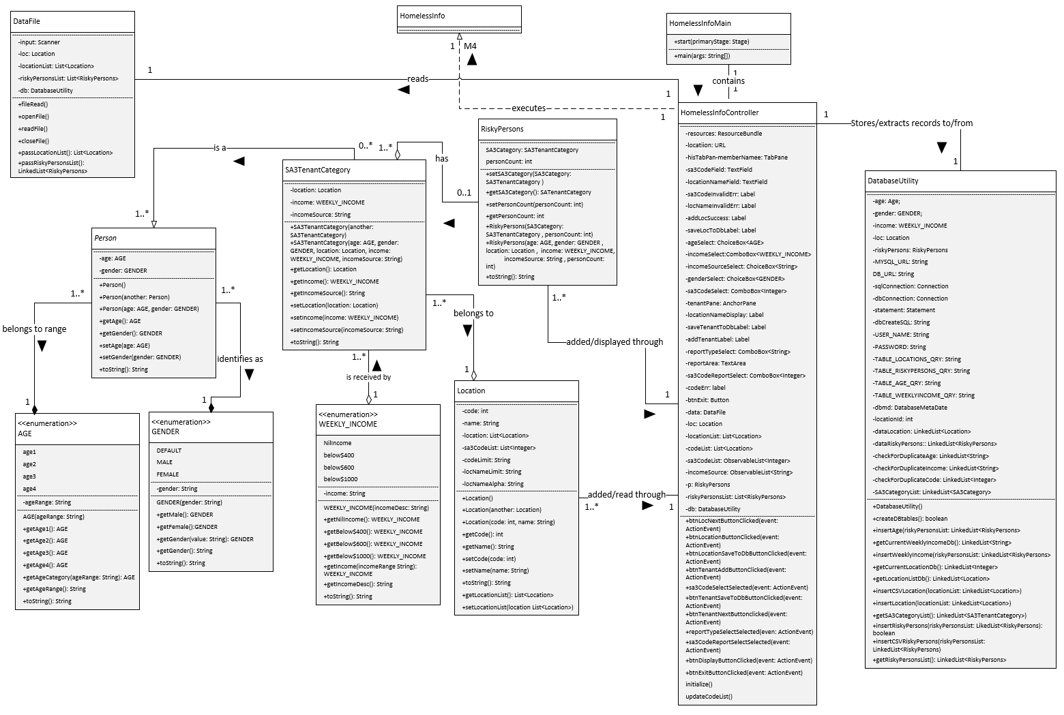

ERD Diagram
Figure 1.2 illustrates the database relationships of the tables inside the homelessinfo database being created from the Homeless Information System. It consists of 4 tables.
- Age table contains the age range description, e.g. income between $600 - $1000. It is identified by AgeId.
- Location table has location code and location name. Location code refers to the 5-digit SA3 code. The records for this table are being identified through the LocationId.
- WeeklyIncome table is identified through the WeeklyIncomeId primary key. It contains WeeklyIncome which refers to the income range description of a tenant.
- Finally, the RiskyPersons table contains gender, income source, and person count. It also references to Age, Location, and WeeklyIncome tbales through the ageid, locationid, and weeklyincome Id foreign keys, respectively.
The below assumptions for the database and the relationships between the tables have been considered:
- An age range can appear in 0 or more persons at risk of homelessness. There might be 0 risky person at a specified age group or there can be more in an age group. (0:M)
- A weekly income can be received by 0 to many risky persons. (0:M)
- The combination of a location code and location name can have 0 or many people at risk of homelessness coming from that specific area. (0:M)
- Lastly, a person at risk of homelessness belongs to one age group, receives one type or salary range, and come from one SA3 area. Therefore, the relationship of RiskyPersons in each associated table – age, location, and weekly income – is one to many. (1:M)

Figure 1.2: ERD Diagram
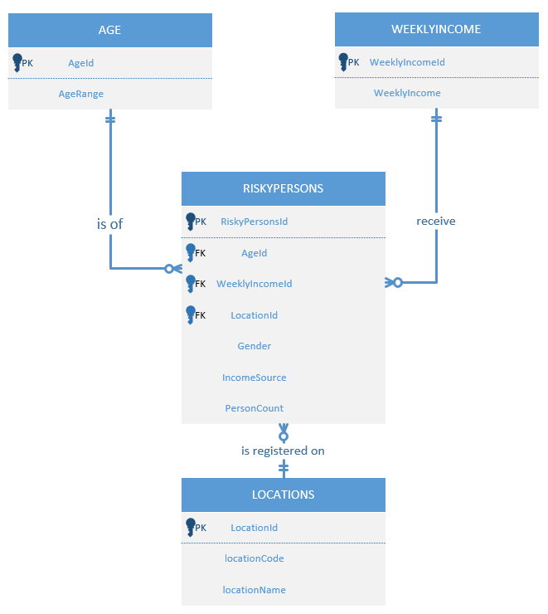

Test Plan
The test plan explores the main features and functionality of the system by performing system execution, data input, displaying of report, and overviewing the database. All the activities have been captured through a screenshot of the actual system.
Important Note
The test has been performed with Mia Megan Macasero, the pair programmer on the development of the Homeless Information System. This has been performed during the final testing of the completed and debugged program. Thus, the screenshots below are the same as hers.

Table 2.1: INITIAL PROGRAM EXECUTION
Test Description | Expected Result | Actual Result
Initial mysql databases | The list of databases should not contain the homelessinfo database as the system has not been executed. | 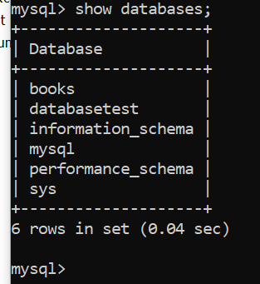  No homelessinfo database enlisted.
Database created on initial execution | Database will be created on the initial execution of the system. Homelessinfo database will be enlisted once show databases; query has been executed.  Confirmation messages of JDBC registration, database, and table creations will be displayed. | 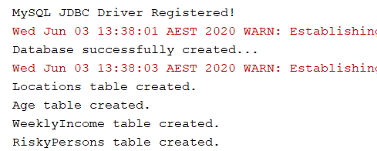  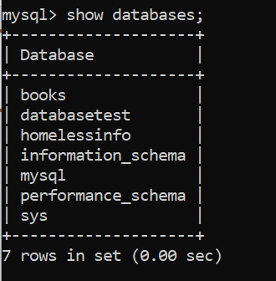  Confirmation messages has been printed and homeslessinfo has been enlisted in after show databases query.
Location table created | The location table created will have 3 initial locations from the future demand csv. | 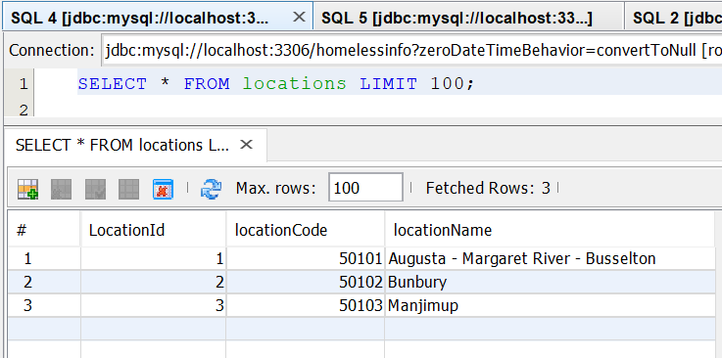  Locations tables contains 3 distinct combinations of location code and location name from the read file.
RiskyPersons table populated | The created RiskyPersons table will be populated with the combination of SA3Category and person count from futuredemand.csv. | 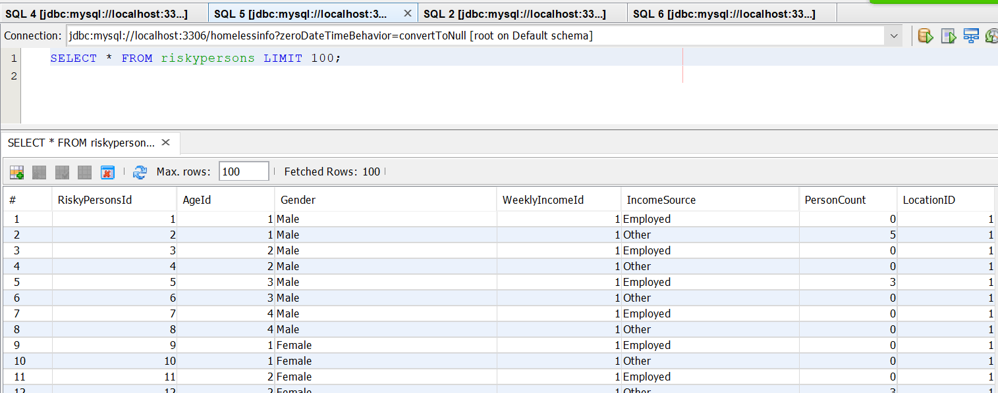  RiskyPersons table has 192 records.
Age table populated | The Age table will be populated with the income range that are in line with the AGE enum values. | 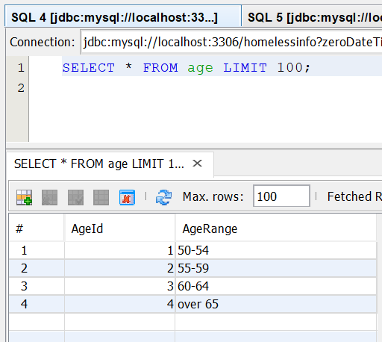  Age table contains 4 records that identifies each risky person age range.
WeeklyIncome table populated | WeeklyIncome table will be populated with the values that are consistent with WEEKLY_INCOME enum. | 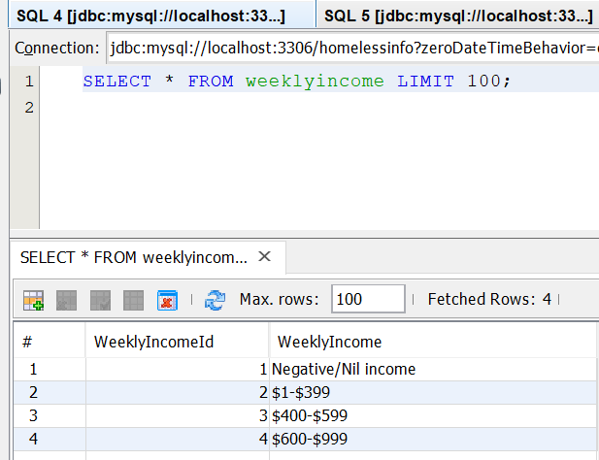  WeeklyIncome table contains 4 records of weekly income values.

Table 2.2: REPORT DISPLAY AFTER INITIAL PROGRAM EXECUTION
Test Description | Expected Result | Actual Result
Male Report displays descending order of Male risky persons. | The report will display RiskyPersons table records with Gender = Male. | 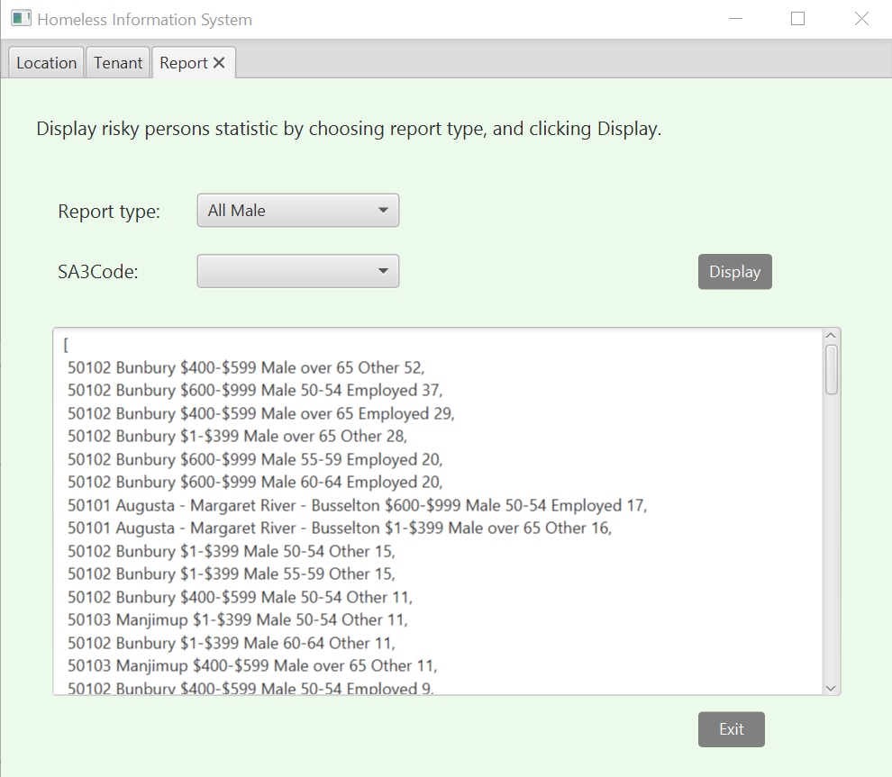  After initial execution, report type All Male displays desired results.
Female report displays descending order of Female risky persons. | The report will display RiskyPersons table records with Gender = Female. | 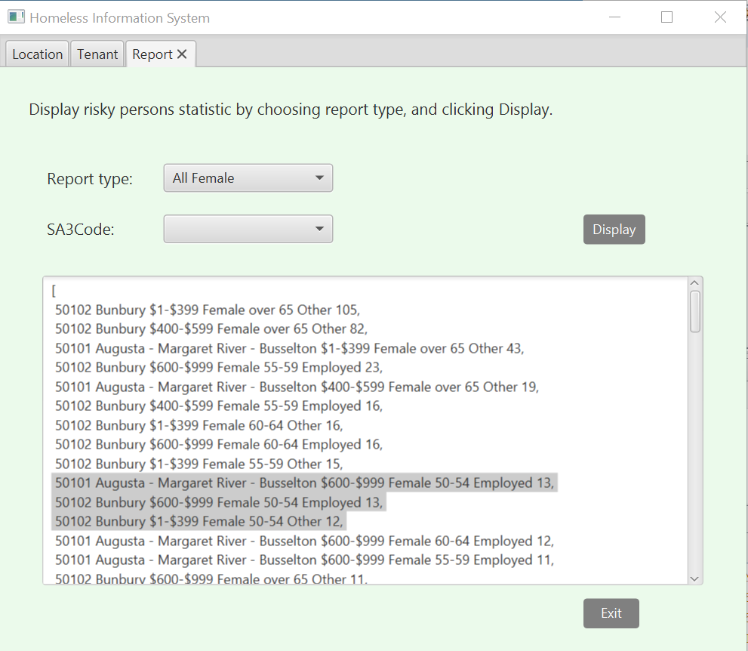  After initial execution, report type All Female displays desired results in descending order.
Report All records | The report will display all of the records in the RiskyPersons table. | 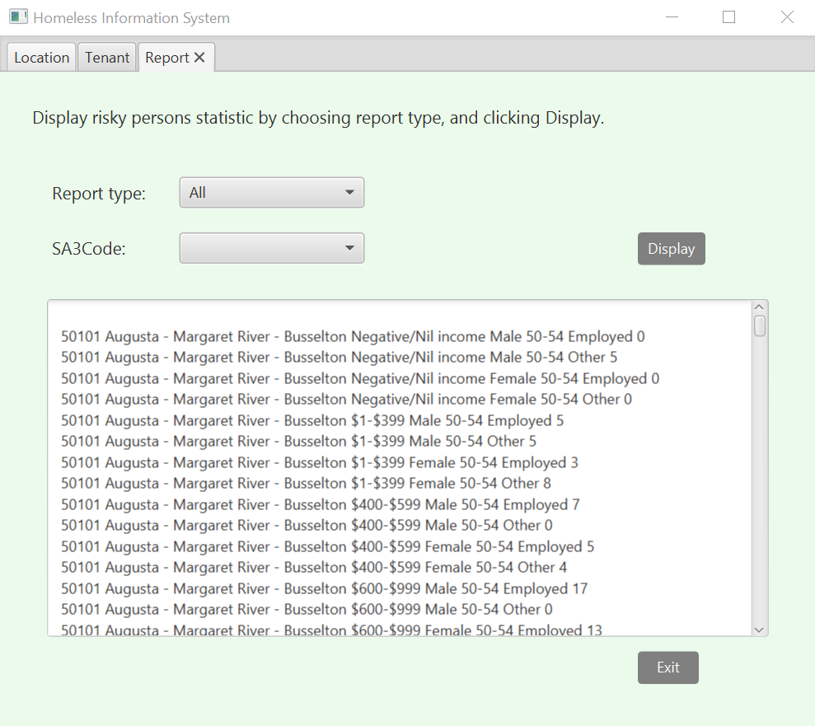  Report type All displays all records in the RiskyPersons table.
Report by Code | The report will display records from the riskypersons table by the specified location code. | 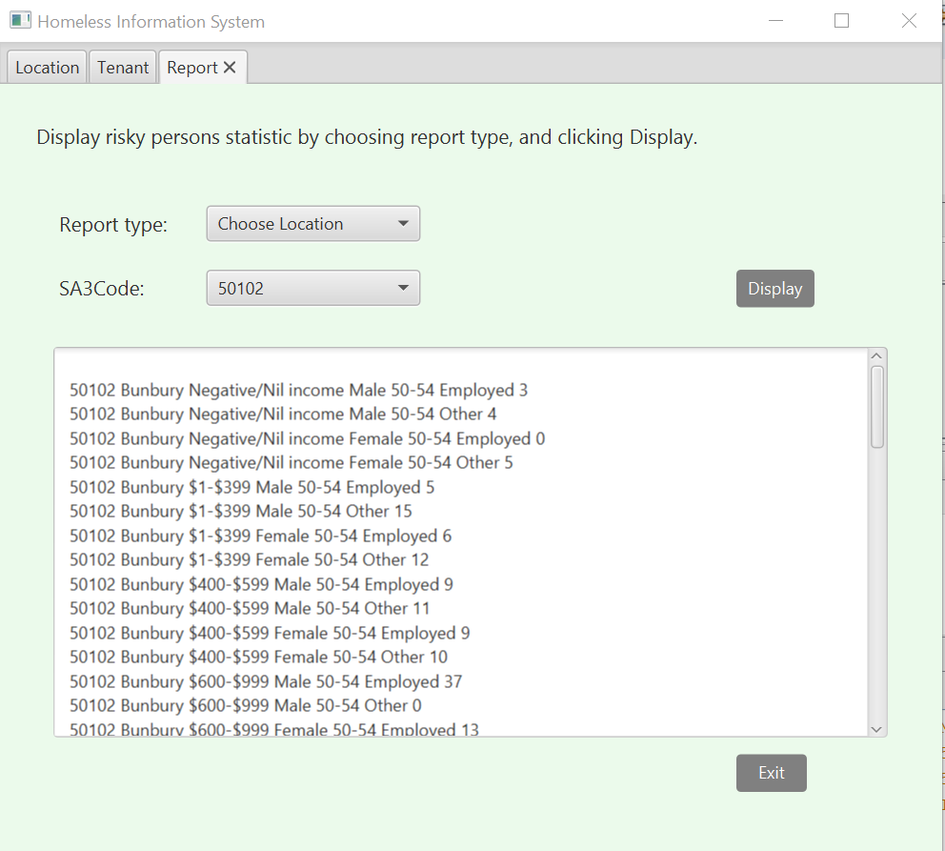  Report type Choose Location with specified sa3 code displays the desired result for SA3 Code = 50102.

Table 2.3: TENANT TAB LOCATION CODE
Test Description | Expected Result | Actual Result
Location code drop down list populated. | After initial program execution, the sa3 code drop down list under tenant will be populated with location code from the Location table. | 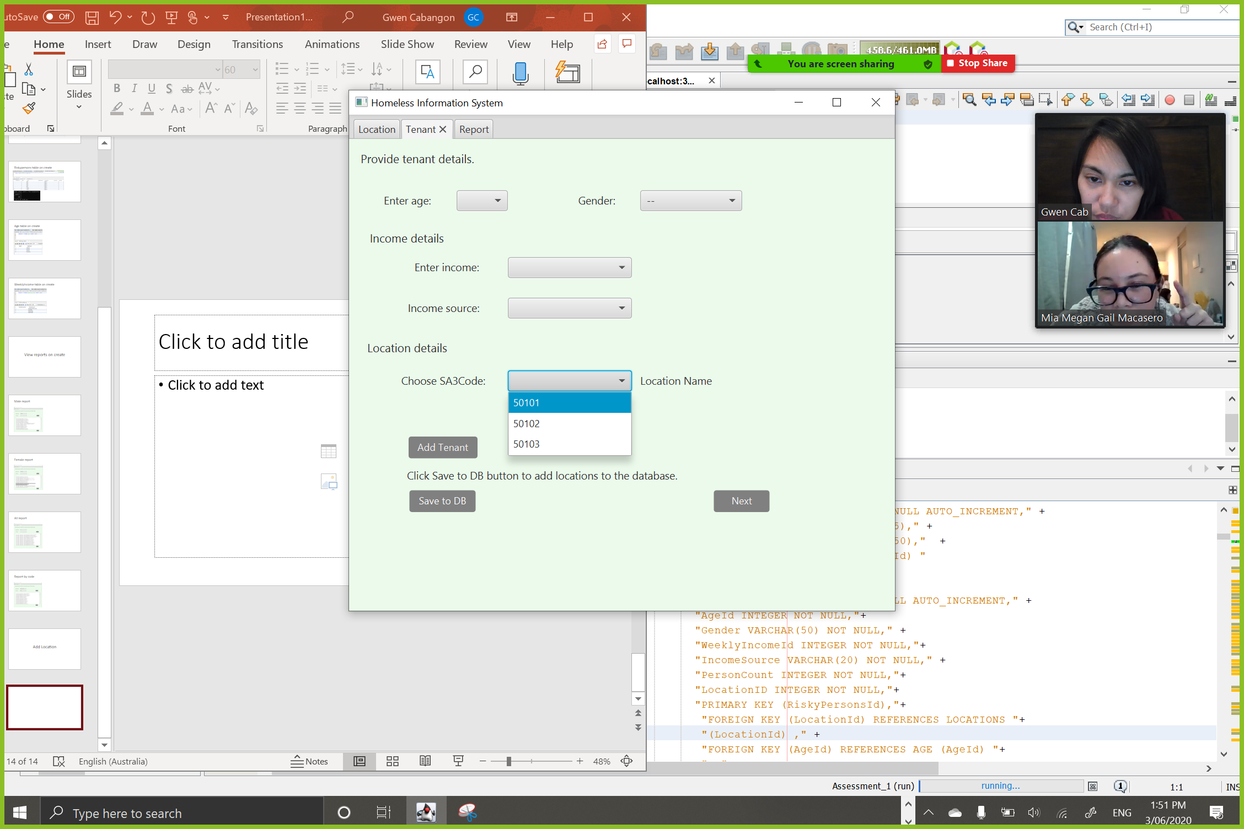  Location code dropdown has been initialized and populated with code which are consistent with the Location table records.

Table 2.4: ADDING LOCATION
Test Description | Expected Result | Actual Result
Adding correct location code and location name combination. | Add location prompt and location saved to database will be displayed, and database will be updated. | Input:  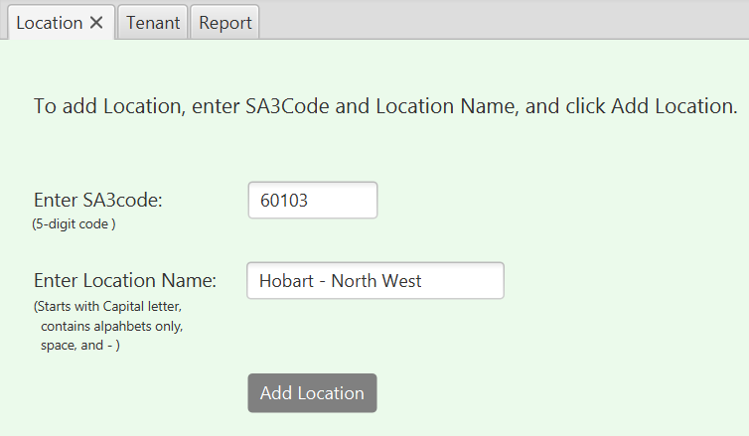  Add location prompt:  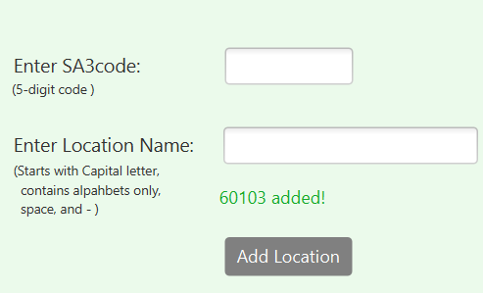  Add to database prompt:  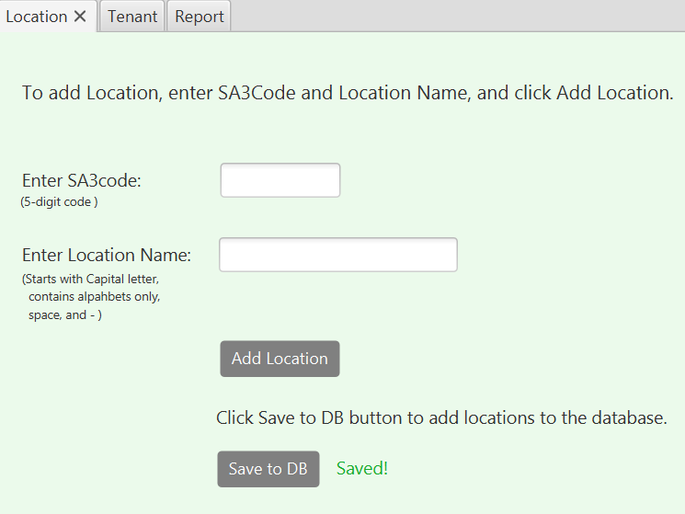  Location database update:  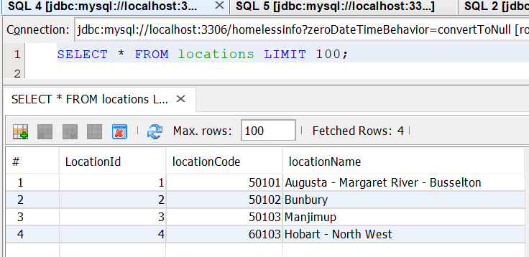

Table 2.5: ADDING RECORD IN TENANT TAB
Test Description | Expected Result | Actual Result
Adding count to existing SA3 Tenant category. | Count of risky person will be updated or incremented by 1 and the number of records in riskypersons table remains at 192. | Database before adding record:  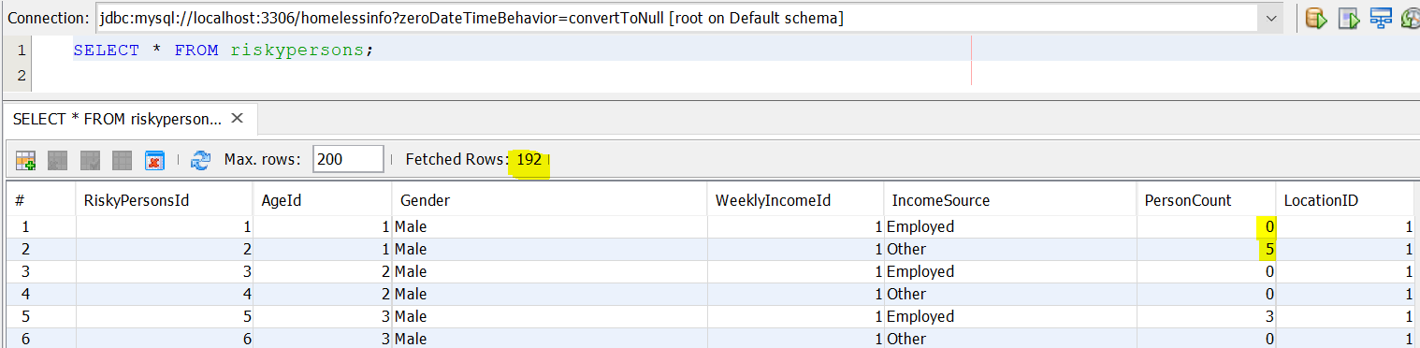  Input:  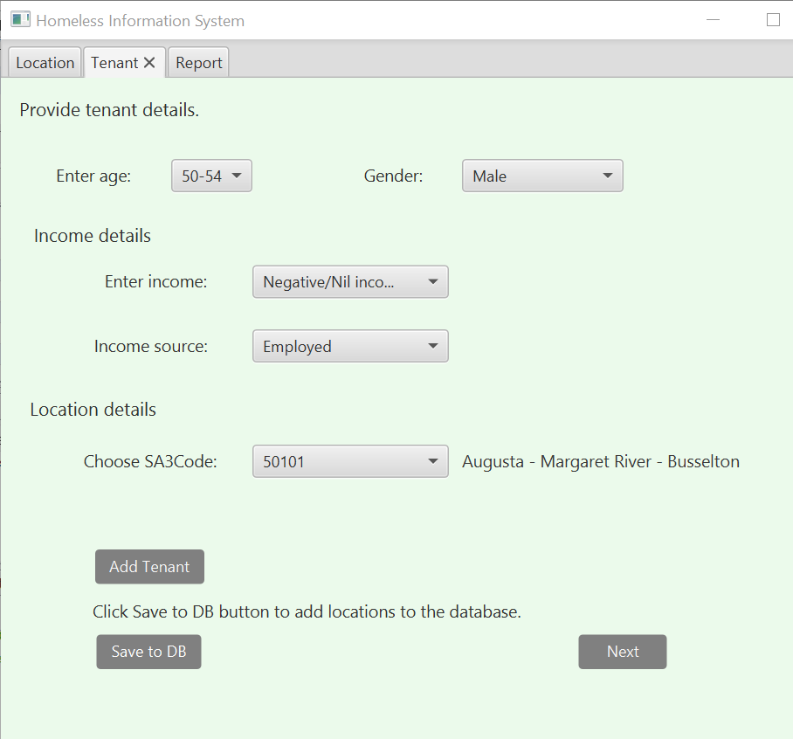  Tenant added prompt:  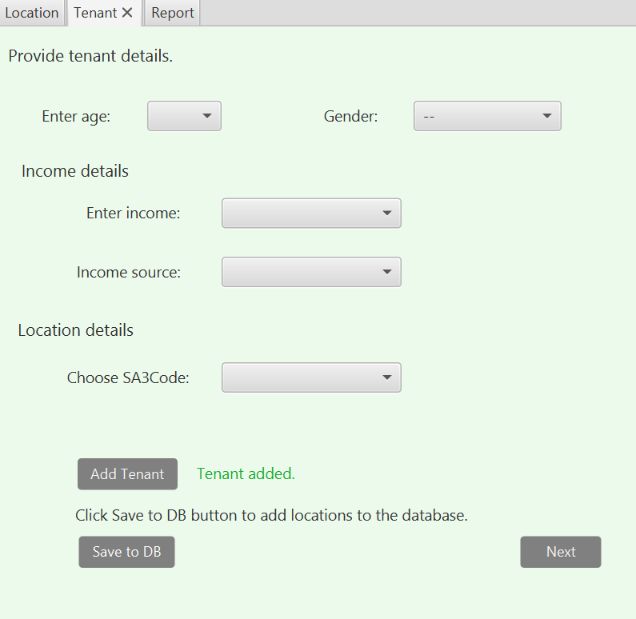  Tenant saved to database prompt:  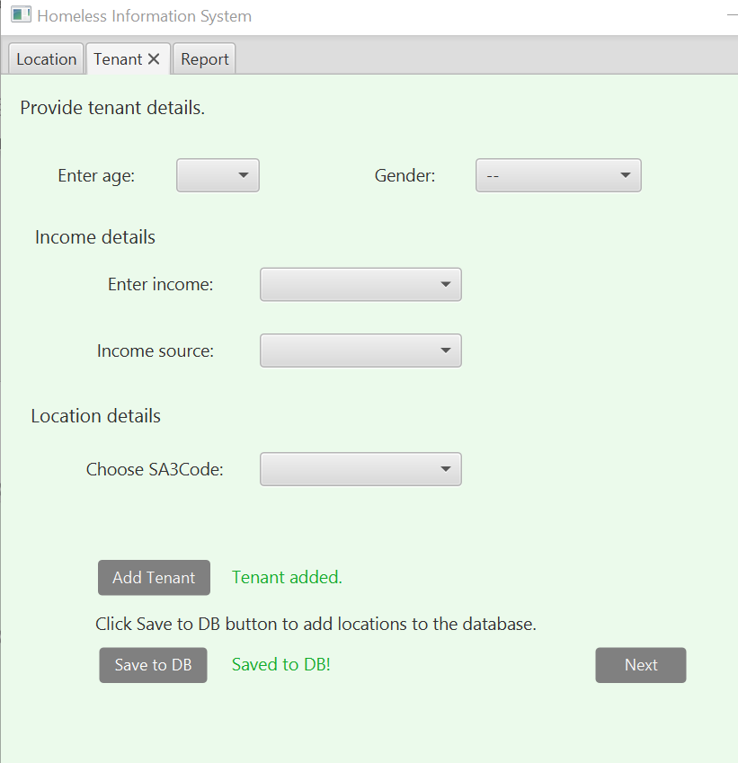  Database updated:  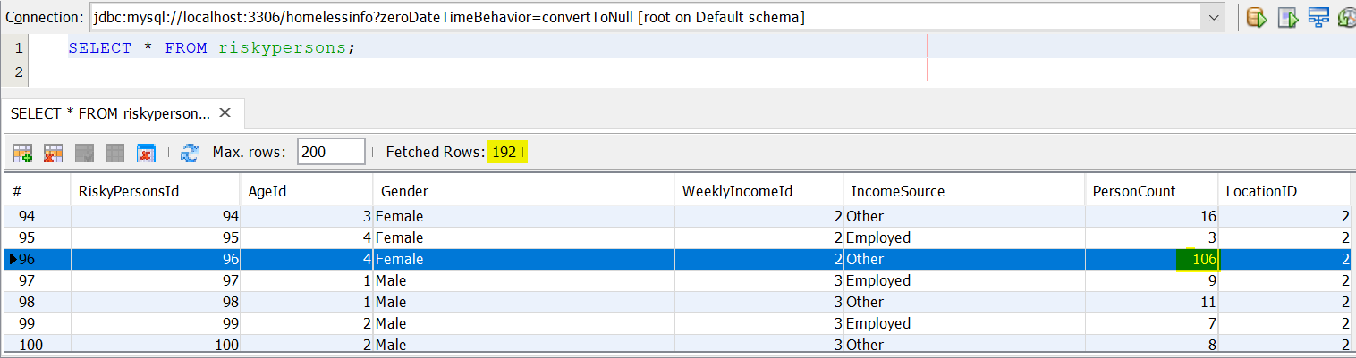
Insert new record to riskypesons table. | New record will be created for a risky person with the newly added location code. The count of riskypersons record will increase to 193. Age, location, and weekly income id’s will match once record has been saved to db. | Input values:  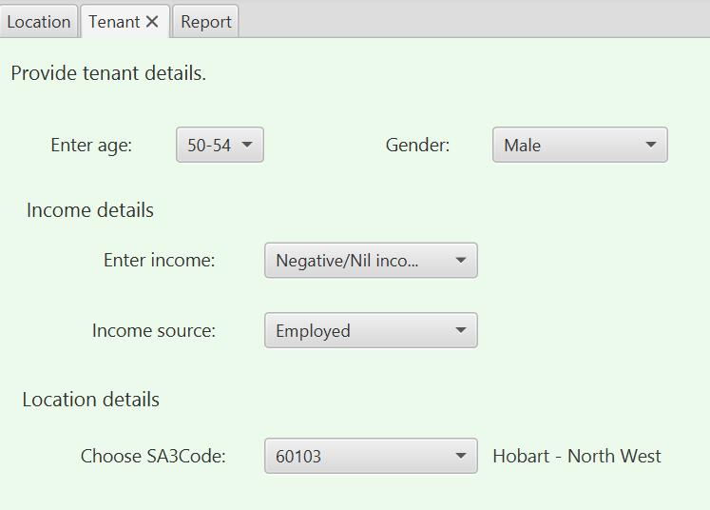  Database updated with 1 new record and count = 193:  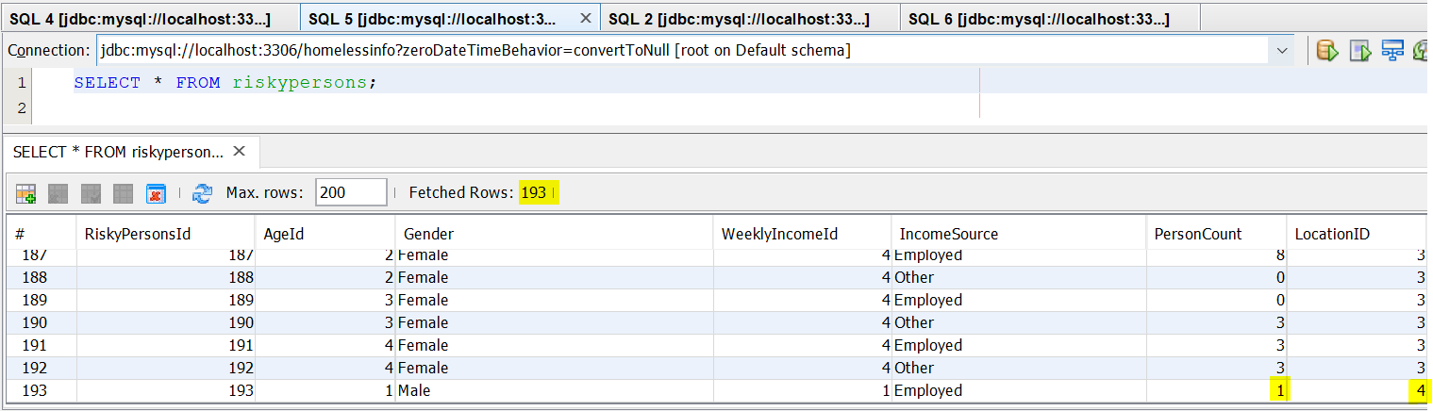
Update newly added riskypersons record. | Increment count of newly added riskypersons record. Count will be equal to 2. | 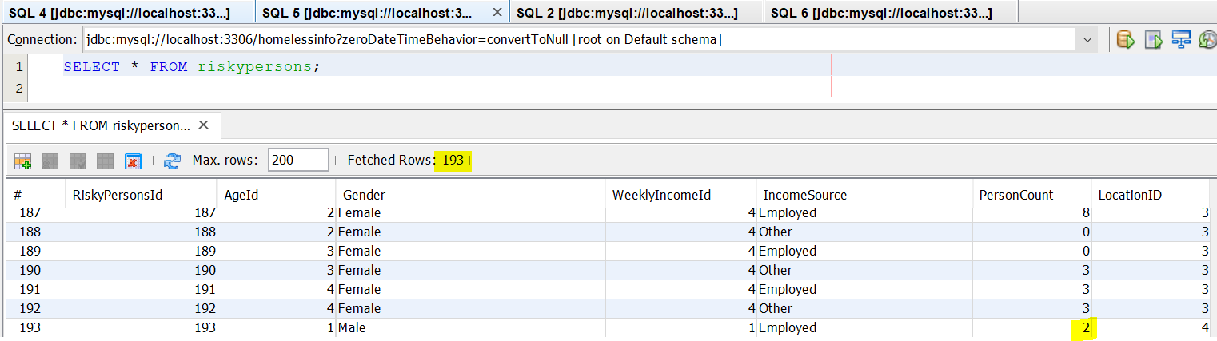  PersonCount = 2.

Table 2.6: REPORT TAB
Test Description | Expected Result | Actual Result
Display report by location code. | Record will be displayed for selected location code. SA3 Code = 60103 will return 1 record. | 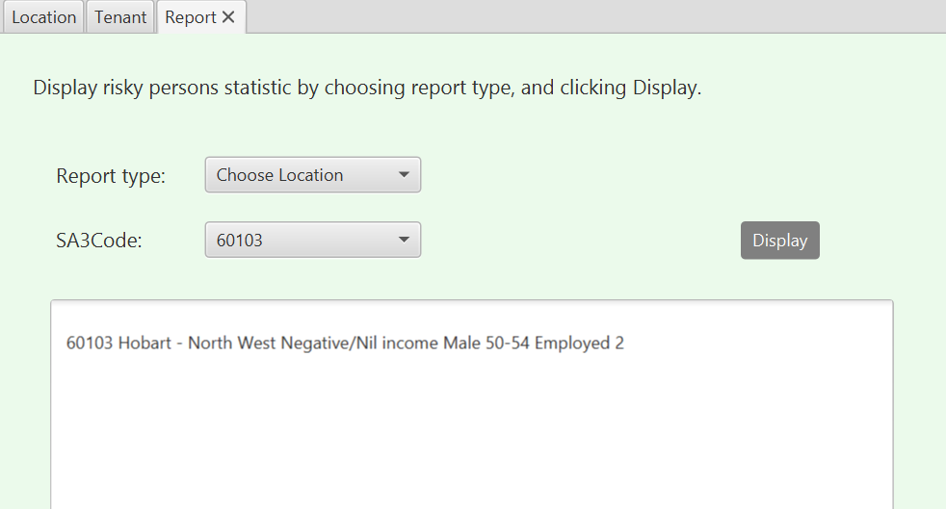  1 record displayed.
Display all records from riskypersons table. | All records will be displayed. | 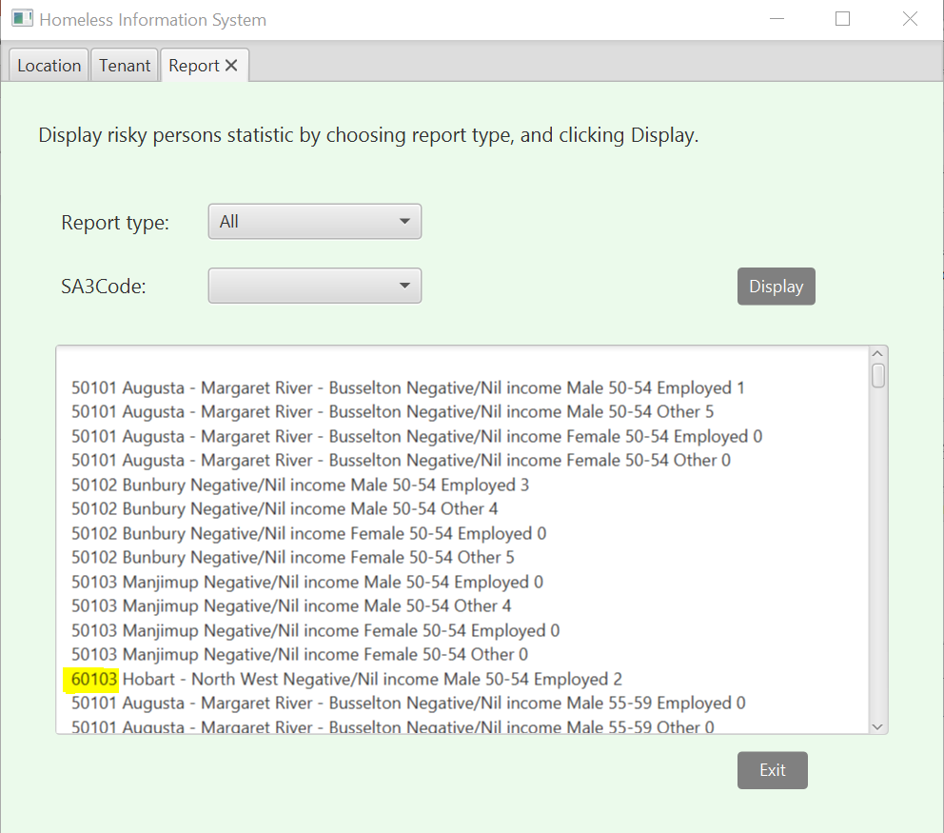  Desired results displayed.
Report all male | Display result for riskypersons where gender = Male in descending order. | 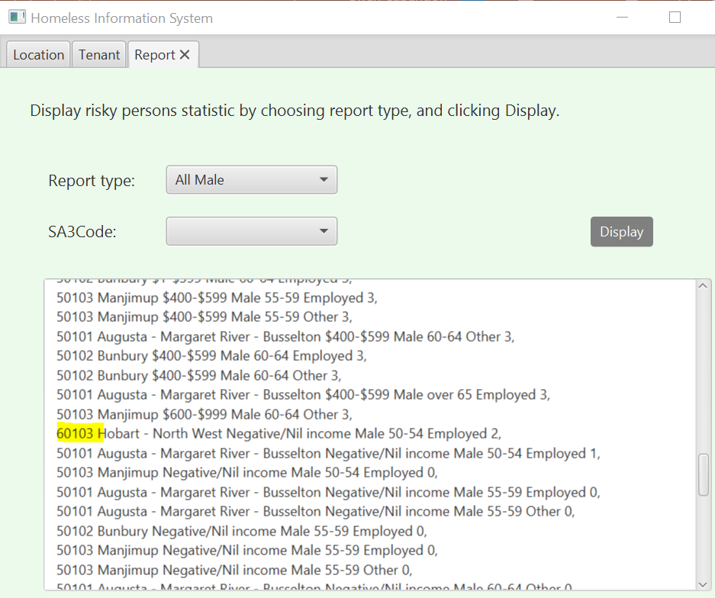  Report displays results in descending order.

Table 2.7: INVALID LOCATION
Test Description | Expected Result | Actual Result
Invalid location code format. | Entering location code with size not equal to 5. Location input will not be accepted, and prompt will be displayed.  SA3 Code = 3030 (4 digits) | Input values:  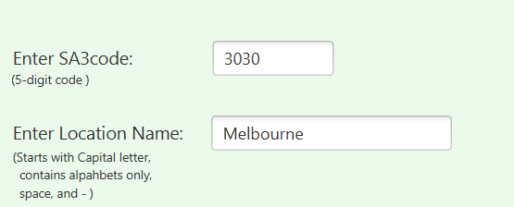  Prompt displayed for input mismatch:  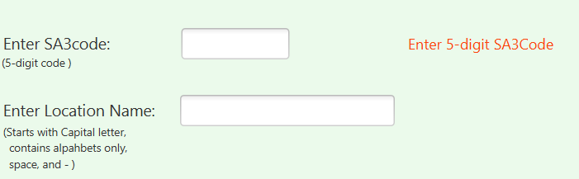
Empty fields submitted. | Empty input fields will be submitted and will not be accepted. Prompt will be displayed. | Input value empty:  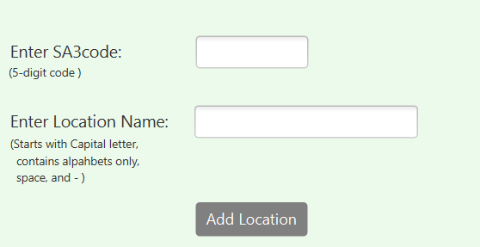  Prompt displayed for submitted null values:  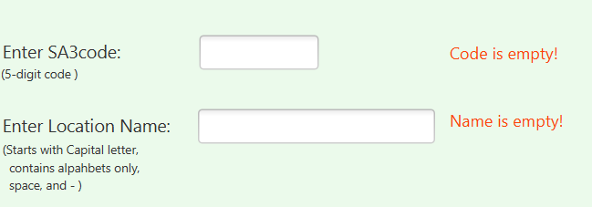
Location Name field empty. | Only SA3 code has been populated and submitted. Submission will not be accepted, and prompt will be displayed. | Input value:  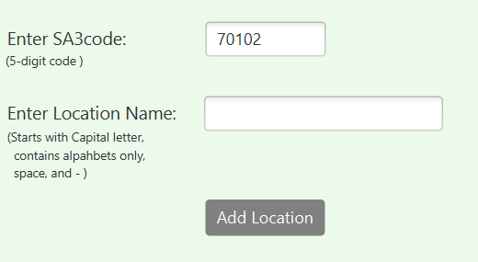  Prompt for empty location name displayed:  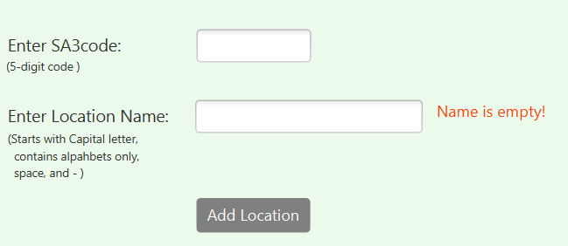
SA3 Code field empty. | Only location name field has been submitted and populated. Submission will not be accepted, and prompt will be displayed. | Input value:  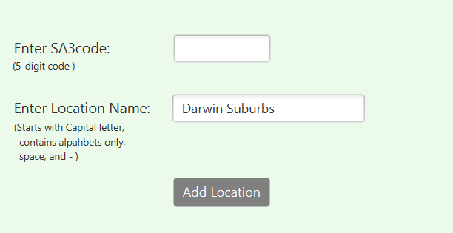  Prompt for empty SA3 Code displayed:  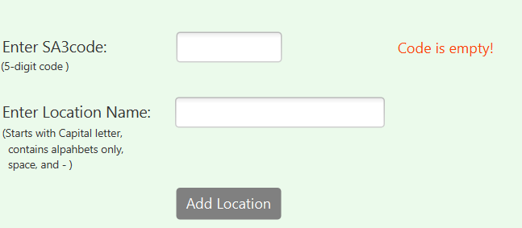
Location name not starting with a capital letter. | Location name starts with a lowercase character. A prompt will be displayed for invalid format. | Input value:  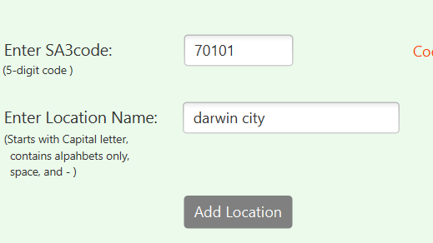  Prompt for invalid format displayed:  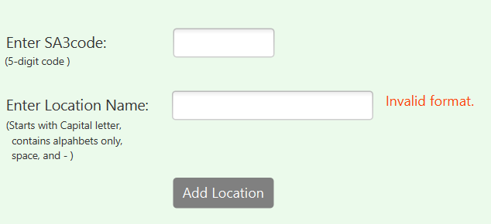
5-digit SA3 Code | The SA3 Code input will contain an alphabet. A prompt will then be displayed for reminding that SA3 Code accept 5 digits only. | Input value:  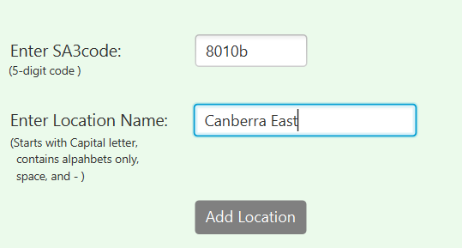  Digit format prompt displayed:  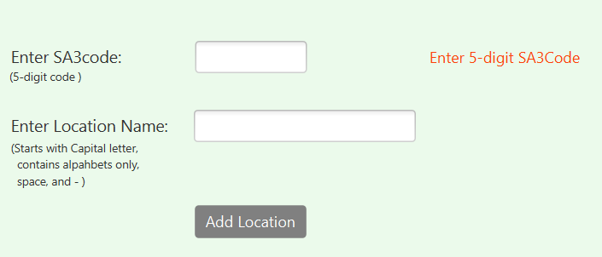

Table 2.8: INVALID LOCATION
Test Description | Expected Result | Actual Result
Empty Input Values. | The dropdown lists in Tenant tab will not be populated and will be submitted.  The submitted values will not be accepted and a prompt will be displayed. | Input values:  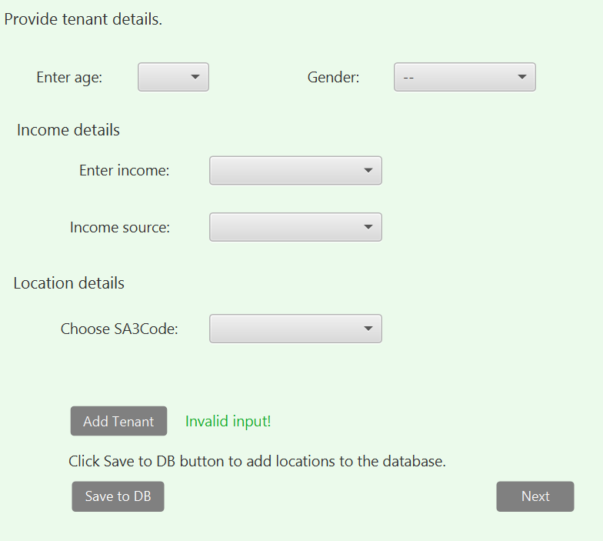  Prompt for unsuccessful database update/insertion:  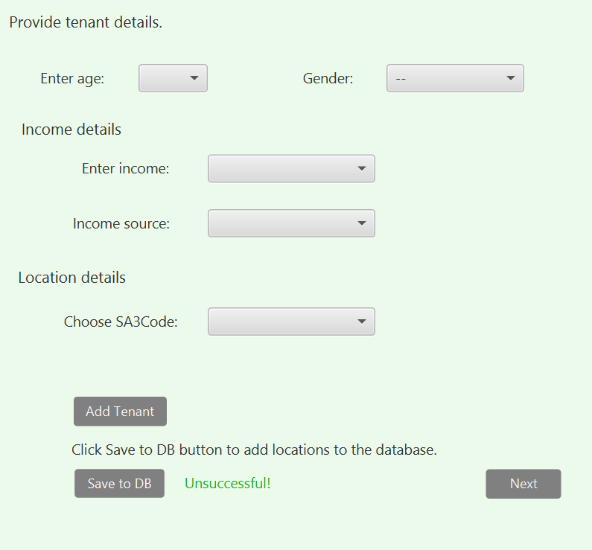

List of Tasks Completed
The tasks completed during the pair programming activity are listed below.

Table 3.1: TASKS COMPLETED
Task | Brief Description | Source File
Modify Assignment 1 source code | Incorporated the solution code to the base code. Improved enum set and get methods, implemented for loop in file reading, incorporated report display, implemented location validation, added method in SA3Tenant, and improved getting object in RiskyPersons. | AGE.java  DataFile.java  DatabaseUtility.java  GENDER.java  HomelessInfoController.java  Location.java  RiskyPersons.java  SA3TenantCategory.java  WEEKLY_INCOME.java
Conversion of database code | Converted statements into PreparedStatement. Rewritten DatabaseUtility into code that is consistent with BooksDatabase sample code from unit tutorial solution. | DatabaseUtility.java
Input validation | Improved intricate location and tenant validation to cover different invalid input scenarios. | HomelessInfoController.java  Location.java
Prompt messages | Added prompts for error and successful input. | HomelessInfoController.java  DatabaseUtility.java
Added method to pass initial list | Added the method to pass initial riskypesons and location records from csv file. | DataFile.java  HomelessInfoController.java
Implemented lambda stream | Replaced for loop to lambda expression to display All Male and All Female report type in descending order. | HomelessInfoController.java
Added methods to get current list from database | Implemented methods that return LinkedLists for validating location, age, weekly income, SA3 category list, and returning riskypersons list.  getRiskyPersonsList()  getSA3CategoryList()  getLocationListDb()  getCurrentLocationDb()  getCurrentWeeklyIncomeDb()  getCurrentAgeDb() | DatabaseUtility.java
UI features | Added labels, css, resized UI window, and action events. | HomelessInfo.fxml  Homelessinfo.css  HomelessInfoController.java
Rigorous debugging | Thorough debugging and code improvement for inserting, updating, extracting, and comparing database records. | DatabaseUtility.java  HomelessInfoController.java
Separate CSV methods | Created separated methods that captures records from csv file and inserting into database. | DatabaseUtility.java
Exception | Implemented exception handling. | DatabaseUtility.java  HomelessInfoController.java
Database insert | Implemented insert validations. | DatabaseUtility.java

